DOI: 10.1002/((please add manuscript number))
Article type: Full Paper

Vertical tunnel junction embedding a Spin Crossover molecular film

Lorenzo Poggini,* Juan H. González-Estefan, Mathieu Gonidec,* Benoît Gobaut, Patrick Rosa.

Dr. Poggini Lorenzo, Juan H. González-Hernandez, Dr. Mathieu Gonidec, Dr. Patrick Rosa, CNRS, ICMCB, UMR 5026, F-33600 Pessac, France
Dr. Poggini Lorenzo, Juan H. González-Hernandez, Dr. Mathieu Gonidec, Dr. Patrick Rosa, Univ. Bordeaux, ICMCB, UMR 5026, F-33600 Pessac, France
Dr. Benoît Gobaut, Synchrotron SOLEIL, L'orme des Merisiers, Saint-Aubin-BP48,91192 GIF-sur-YVETTE CEDEX, France

E-mail: lorenzo.poggini@icmcb.cnrs.fr, mathieu.gonidec@icmcb.cnrs.fr.

Keyword SCO, EGaIn, Tunnel Junctions, Thin films

Abstract: Thin films of a molecular spin crossover Iron(II) complex featuring a high transition temperature have been grown by sublimation in high vacuum on ^{TS}Au, and investigated by X-ray, UV photoelectron spectroscopies, tunnelling junctions with top electrodes of the liquid eutectic of gallium and indium (EGaIn) supported by DFT calculations. Temperature-dependent studies demonstrate that the thermally induced spin crossover behaviour is preserved in thin films. We report here the first ultra-thin switchable spin crossover molecular vertical tunnel junction in which the spin-state switching of the films induces a two orders of magnitude change in the tunnelling current density flowing through the junction. Those results on large-area junctions demonstrate the high potential of SCO-based switchable molecular junctions as functional devices.

Introduction
From the technological point of view Spin Cross-Over molecular (SCO) materials have been proposed for numerous applications ranging from memory devices,^{[1]} to gas, pressure and temperature sensors.^{[2,3]} SCO materials are proposed to be good candidates as active components in prospective spintronics and molecule-based data storage devices^{[4–6]} as well as in innovative devices taking advantages from additional features, combining SCO with other functionalities.^{[7]} Considering all those possible applications, the study of the electrical properties of SCO compounds is fundamental, to understand how they behave under electronic stimuli, especially when prepared as thin films.^{[8]} Indeed, these molecules can be switched between two electronic states – termed high-spin (HS) and low-spin (LS) – with different magnetic, optical and structural properties by the action of external stimuli (pressure, temperature, light-irradiation)^{[9–13]} making them promising systems for new functional materials.^{[14]} This is particularly important since the use of electrical stimuli to control (read/write) the spin-state of the system would provide a great advantage towards technological applications, compared to other conventional addressing methods such as light irradiation, and changes in temperature or pressure, that are less easily implemented. In this paper, we show that it is possible to design switchable molecular tunnel junctions, in which the tunnelling barrier is made of a thin film of a SCO compound. Those thin films, made by evaporation on ^{TS}Au (templated-stripped gold), were thoroughly characterized using highly-sensitive and speciﬁc surface tools. Electrical switching has been studied as a function of temperature in a tunnel junction configuration, and the experimental results have been rationalised thanks to a theoretical model based on energy levels and electronic densities obtained at density functional theory (DFT) level. The good correlation we establish between experimental measurements and modelling proves the feasibility to design, manipulate and read such ultra-thin film devices, an important prerequisite for the development of future active multi-stable devices. The most critical issues toward the development of large-area spin-crossover based molecular junctions are i) to obtain high quality SCO thin films over large areas and ii) to have a measurement methodology that allows to measure their properties in an efficient and reliable manner. Moreover, to facilitate further developments and applications of those systems, it is highly desirable to have a transition temperature (and thus, possibly, a switching temperature) close to room temperature. For those reasons, we have chosen the [Fe(HB(trz)₃)₂] SCO complex, hereafter called 1 (HB(trz)₃ = tris(1H-1,2,4-triazol-1-yl)borohydride),^{[15–18]} for which it was shown recently that it can be deposited as continuous thin films on surfaces by thermal evaporation.^{[19,20]}
Some recent efforts have focused on vertical large area SCO junctions operating in the hopping regime, with film thicknesses in the 100-nm range by evaporation of metallic top contacts over the molecular films on a closely related SCO complex.^{[21]} This methodology works well for rather thick films (a few tens or hundreds of nm), but for thinner films – of ca. 1-5 nm, as may be required to obtain good quality tunnel junctions – it is likely to yield an unacceptably high amount of shorted devices. Similar results were very recently published using the same approach with the [Fe(HB(trz)₃)₂] complex, for films ranging from 10 to 200 nm,^{[22]} but reported no significant variation of tunneling conductance with temperature for films of 10 and 30 nm thicknesses. This may be, in part, due to either interpenetration of the molecular thin film and the evaporated top electrode, or to the rigid nature of the latter, as the sensitivity of SCO compounds to external pressure leading to inhibition of spin state switching is known, and it is reasonable to think that this should be exacerbated for thin films .

Results and discussion
In the present study, we measured vertical SCO molecular junctions by using a soft conformal EGaIn (for Eutectic Gallium Indium alloy, 75% Ga and 25% In in mass, see schematic representation in Figure 1a) top electrode that specifically addresses the main challenges one can expect to encounter when measuring vertical SCO junctions. In particular, this top electrode provides a soft, deformable top contact which should ensure that the molecular film is intact (i.e. not breached by the top electrode) even at very low thicknesses; it should also provide mechanical compliance of the electrode with the deformation of the molecular film, while ensuring a small footprint which should minimize the occurrence of short-circuits. This type of soft top electrode has been used by us and others to study molecular tunnel junctions with great efficiency^{[23–27]} and has recently been employed to study inorganic complex systems.^{[28–30]} In our hands using an EGaIn top electrode afforded tunnel junctions with a two orders of magnitude abrupt change in conductivity at the crossover temperature.

Bulk and Thick Film Magnetic characterization
Magnetic characterization of the thermally driven SCO in a 100 nm thick film on a Kapton substrate has been carried out with a SQUID magnetometer and compared with a bulk powder sample measured with a VSM magnetometer (see Figure 1b). 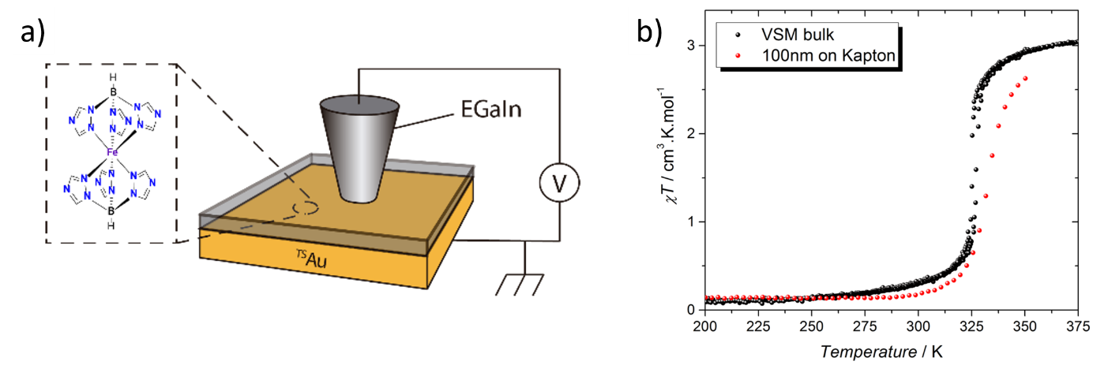
Figure 1. a) schematic representation of the ^{TS}Au//SCO//Ga₂O₃/EGaIn junction with the structure of 1 represented in the inset and b) VSM measurement of the purified starting material (black dots) under 10 kOe, and SQUID measurement of a 6×90 mm 100 nm thick strip of complex sublimated on Kapton foil (red dots).

The measurement on the bulk powder shows a transition temperature T_{1/2} of 326 K with a small 3 K hysteresis, in line with the values of T_{1/2} recorded previously for the dehydrated complex (magnetic measurement gives 333 K^{[18,19]} and Raman spectroscopy about 325 K^{[18]}). The 390 K χ_{M}T value of 3.08 cm³.K.mol⁻¹ is higher than that previously reported, which was slightly below the expected spin-only value (3.00 cm³.K.mol⁻¹), contrary to what is expected for HS Fe(II) (values typically in the range 3.1-3.8 cm³.K.mol⁻¹). The microcrystalline powder sample of complex 1 is therefore almost fully high-spin at 390 K, and becomes almost fully LS at low temperature, reaching a χ_{M}T value of 0.1 cm³.K.mol⁻¹ at 200 K.
The thin film on Kapton shows a very similar behaviour, with an almost fully diamagnetic state at low temperature with a χ_{M}T value of 0.14 cm³.K.mol⁻¹ at 200 K. The highest temperature that can be reached with the Kapton tape without damaging it was 350 K, and the spin crossover is still incomplete at that temperature (2.63 cm³.K.mol⁻¹ at 350 K), illustrating a slightly more gradual character than in the bulk sample. The observed T_{1/2} of 333 K is again in line with previously reported measurements for both hydrated^{[15,31]} and dehydrated complexes, and the thermal hysteresis width (if significant) is reduced to less than 1 K. A comparison between the thermal switching of the pristine powder sample and the sublimated film reveals that the nanostructuration has an effect on the compound, in particular inducing a slightly more gradual SCO transition and increasing the residual LS fraction at high temperatures (incomplete SCO). These findings may arise from packing inhomogeneity, similarly to what was previously found for doped SCO systems ^{[12,32]} that imposed a different cooperative mechanism than the pure compound.^{[9,33–37]}

Surface characterization
To further confirm that 1 has been deposited intact on the ^{TS}Au surface in low coverage regime, XPS (X-ray Photoelectron Spectroscopy) experiments were performed on 5 nm thin film, and the semi-quantitative results are reported in Table S1. We further checked the integrity of 1 after thermal deposition by in- UPS (Ultraviolet Photoelectron Spectroscopy) and synchrotron-based XAS (X-ray Absorption Spectroscopy).
We analyzed the N1s, B1s and Fe2p XPS regions to evaluate the atomic compositions of the functionalized surfaces (see Figure S1 and Table S1). For thin films of 1 evaporated on ^{TS}Au, the N1s region features two main components with a 2:1 intensity ratio (Figure S1, middle) at 401.1 and 399.7 eV (64% and 36%, respectively) assigned to the two coordinated nitrogen atoms of the triazole ring and to the unsubstituted nitrogen atom and, respectively.^{[38]} The line shape of the B1s band (see Figure S1, right) is also consistent with the chemical formula of complex 1.^{[39]} The semi-quantitative analysis (see Table S1) thus confirms the chemical integrity of complex 1 after thermal deposition on ^{TS}Au.
To follow the SCO transition we acquired XPS and UPS spectra at 298 and 360 K, and XAS at 100 and 350 K. In the XPS spectra (see Figure 2a) the Fe2p region is clearly different at 300 and 360 K thus providing evidence for thermally induced SCO in the 5-nm films. The occurrence of SCO is particularly clear when considering the Fe2p_{3/2} peak that is centred at 710.5 eV in the HS state and at 709.5 eV in the LS configuration. In the LS state this peak also appears narrower, and is principally dominated by a component at lower binding energy (709.5 eV, highlighted in green and called A) which is known to be due to the coupling of the photoelectrons with the partially-filled metal shell.^{[40]} The spin-orbit splitting (ΔE_{SO}) value also changes significantly upon conversion, with values of 13 eV and 12.5 eV for the HS and the LS components, respectively, which is in good agreement with previously reported values.^{[41–44]} Indeed, ΔE_{SO} changes upon SCO due to different orbital populations in the two spin states: in the HS configuration the measured transition involves e_{g}-like orbitals that are unoccupied in the LS state. We used a peak fitting procedure (Figure 2a) to deconvolute the spectra. The intensity of the components unequivocally attributable to the LS state (A and A’ in Figure 2a) allow, qualitatively, to follow the SCO transition. XPS Binding Energies (B.E.), percentage of the different component, and spin-orbit splitting values (ΔE_{SO}) are reported in Table S2. ^{[44,45]}
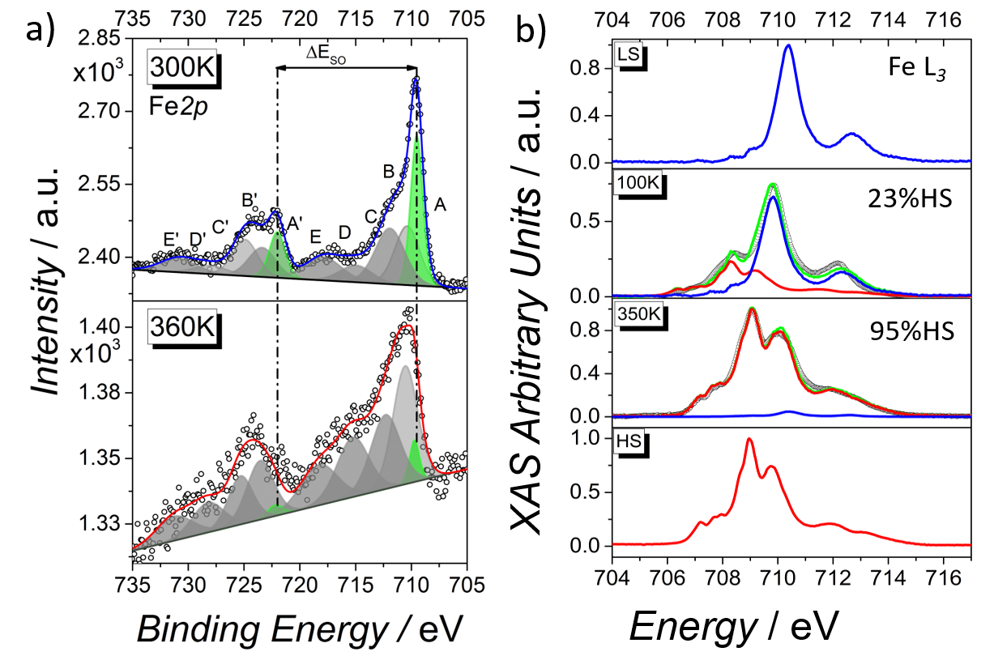
Figure 2. (a) Temperature dependence of the Fe2p XPS spectra evidencing thermal SCO behavior for 5 nm thick films of 1 on ^{TS}Au and (b) temperature evolution of the normalized Fe L₃ edge XAS spectra of a thermally evaporated 5 nm thin film of 1 (empty black dots) along with high-spin Fe (II) and low-spin Fe (II) spectra obtained from the bulk (red and blue lines, respectively) and used as reference signals for the spectral linear interpolation (green lines).

Further evidence for the occurrence of thermally driven SCO in the thin films of 1 on ^{TS}Au were obtained from UPS by analysing the film at 300 and 360 K. This characterization, performed on the pristine film at 300 and 360K K (corresponding to the LS and the HS states, respectively) was compared with a DFT-based modelling that helped to clarify the observed effects. The UPS spectrum acquired on a 5 nm film at 300 K (Figure S2, blue line) evidences a HOMO contribution at -2.82 eV, in agreement with similar systems^{[7,43,46,47]} and the TDOS obtained from the DFT calculation results starting from the LS crystal structure. The temperature effect on the UPS spectra is visible mainly in the valence-Fermi region (from 0 to 6 eV). Indeed, upon warming up from 300 to 360 K, we observed a shift to -2.35 eV (Figure S2, red line) in line with what was previously reported for similar SCO compounds,^{[7,43,44,46,47]} and again in very good agreement with the TDOS obtained from the DFT calculations results starting from the HS crystal structure. Our in-house spectroscopic analysis points out that evaporated ultrathin films of 1 on ^{TS}Au, retain the switchability of the bulk complex 1 even after thermal sublimation.
A quantitative analysis of the population of the HS and LS states was also made by XAS measurements, since absorption techniques are unmatched tools to qualitatively and quantitatively analyse ultra-thin layers of molecular systems, providing the required sensitivity to monitor the spin state of the investigated system.^{[35,48–51]} Figure 2b displays the Fe(II) L₃ edge absorption spectrum of a 5 nm thin film of 1 on ^{TS}Au at 100 K and 350 K. The 100 K spectrum clearly shows coexistence of LS and HS forms, which is in line with what we observed by magnetometry for 100 nm films evaporated on Kapton (Figure 1b). Upon heating from 100 to 350 K the spectral features related to HS-Fe(II) increase from a contribution of about 23% to ca. 95%, respectively (see methods for details). Atomic force microscopy (AFM) imaging measured on thin films of 1 (see Figure S3) showed a rather smooth surface to confirm a nice defect-free SCO deposit excluding the presence of defective areas or Vollmer-Weber growth. The AFM estimated roughness in an area of 4 μm² resulted at about 0.4 nm (Figure S3).
Electronic measurements
In the light of the quality of the films we obtained, we incorporated the 5nm SCO deposits on ^{TS}Au in vertical tunnel junctions using an EGaIn top electrode as depicted in Figure 1a. The choice of the substrate is dictated by the necessity to use an ultra-flat bottom electrode to obtain functional, non-shorted junctions, over hundreds of square micrometres. We contacted those thin films with EGaIn conical tips top electrodes as described elsewhere,^{[27]} and made contacts of ca. 100 μm in diameter. We controlled the temperature of the system with a Linkam microscope stage, and the resulting J/V curves exhibited the typical non-linear behaviour expected for non-short-circuited tunnel junctions. The high reproducibility of the measurements and the absence of short-circuits are a further confirmation of the high quality of the 5 nm SCO films we used in the junction, and of the reliability of EGaIn as the method of choice for measuring such systems.
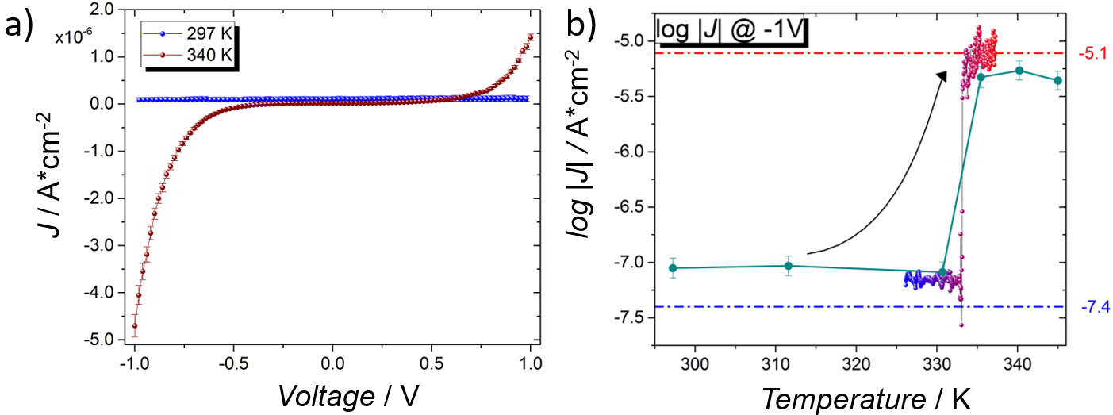
The J/V curves registered at 297 and 340 K (corresponding to the temperature of LS and the HS states determined by magnetometry, XPS and XAS, respectively) are very strikingly different, and they provide evidence for switchable junctions with a clearly different behaviour depending on the spin state of 1 (Figure 3a).Above T_{1/2}, with compound 1 in the HS state, the tunnelling current density at 1 V applied bias potential is about two orders of magnitude higher than for the LS state (with tunnelling current densities of ≈ 5×10⁻⁶ A.cm⁻² to≈ 6×10⁻⁸, respectively). We also noted that the HS junction presents a moderate negative rectifying behaviour, with the current flowing under negative bias being slightly larger than the one flowing at positive bias. The complete series of J/V curve from 297K to 450K is reported in Figure S4.
Figure 3. a) J/V curve at 297 K and at 340 K, blue and dark red dots respectively acquired with a rate of 15 mV.s⁻¹; b) log |J| at V=-1 V reported as a function of temperature acquired like single point (dark cyan dots, see Figure S4) and in sweeping mode using a rate of 1 K/min (from blue to dark red dots); the curved arrow is a guide for the eyes to emphasize the jump in electrical conductivity; the two horizontal lines are the log |J| value of HS and LS states obtained by our modified Simmons’ model simulations (red line and blue line respectively).

To investigate the temperature-driven switching behaviour of the junction more in depth, and to verify that the great difference in current density we observed between low and high-temperature data truly arises from the change of the spin state, we characterized the junctions at different temperatures. Figure 3b shows the obtained values of log |J| measured at an applied bias of -1V (+1 V and -1 V for comparison are reported in Supplementary materials, Figure S5). To establish just how abrupt the switching phenomenon is, we repeated the measurements while increasing the temperature at a rate of 1 K/min. Both measurements show the same abrupt change in current density of approximately two orders of magnitude in the temperature window in which we expected the SCO to happen, at a critical temperature T* of 333 K (we report the complete series of log |J|/V curves in Figure S4 together with Fowler-Nordheim plots in Figure S6). In general, the current densities we observed are 1-3 orders of magnitude lower than those reported previously for a twice as thick 10-nm film, in an ITO/SCO/Al junction.^{[22]} This could, in part, be explained by the moderate change in work functions, and the fact that evaporated electrodes are known to display much higher current densities than EGaIn or mercury electrodes due to the improved effective contact with the underlying layer.^{[27]} Nevertheless our junctions presented an abrupt SCO-induced conductance switching. This discrepancy could be linked to the soft nature of our top electrode that – unlike rigid, evaporated top electrodes – permits the required geometrical deformations of the molecular thin films at the transition temperature.
Theoretical Model
To rationalize the experimental data – and in particular to explain the magnitude of the change in current density caused by the SCO – we modelled the behaviour of the junctions with a single-orbital Simmons-like formalism that combines molecular orbital energies – obtained from gas-phase density functional theory (DFT) calculations – and experimentally determined temperature-dependent high-spin fractions. We thus sought to reproduce the trends in tunnelling current density as a function of temperature. For tunnel junctions consisting in a monolayer of molecules sandwiched between two electrodes, it has been shown that the model developed by Simmons’^{[52–54]} provides a reasonably simple way to describe the current flowing through the system.^{[55,56]} Nevertheless, this model applies to homogeneous monolayer thin films consisting of a single compound, and it is not directly applicable to mixed multi-layer stacks made up of compounds with different electronic configurations. We therefore adapted the classical Simmons’ model to describe such a system – by taking into account a random distribution of HS and LS molecules – to compute the temperature dependent tunnelling current density by adjusting the statistical population of the two states to the one determined experimentally (see the details of the model in the SI). We used DFT at the B3LYP/6-31++G(d,p) level to estimate the gas-phase energies of the HS and LS compounds, and computed their approximated TDOS by homogeneous broadening of the orbital energies combined with a rigid shift of 3.5eV which provided DOS spectra that matched reasonably well the experimental UPS data (see Figure S2). Combining the uncorrected orbital energies obtained by DFT with our mixed multi-layer Simmons-like model, we could simulate the tunnelling current density as a function of temperature, by taking the temperature-dependent HS fraction we determined experimentally. The curves generated by using magnetometry data on bulk samples and thin film samples (see Figures S7) provide a reasonable agreement with the experimental current densities for the HS and LS states, with a small discrepancy between T_{1/2} and T* (8 and 1 K, respectively). They fail to reproduce the abrupt transition observed experimentally, exceedingly so for such a nanoscale SCO system, exhibiting instead a more gradual conversion. Nevertheless, it is remarkable that the resulting plots, based on gas-phase DFT calculations and tabulated work functions, provide good estimate of absolute current density values reported like dotted lines in Figure 3b (red and blue for HS and LS, respectively). While our tunnelling data differ significantly from earlier reports, the striking agreement between our experimental and theoretical values is a strong argument in favour of using soft, conformal contacts (like EGaIn) instead of rigid evaporated metallic top electrodes for the characterization of transport properties of soft, pressure-dependent molecular ultrathin films.
Conclusions
In conclusion, we have shown through a detailed spectroscopic analysis that it is possible to prepare high-quality continuous ultrathin films of the [Fe(HB(tz)₃)₂] spin-crossover complex on gold, and that such thin films can exhibit a SCO behavior similar to that of the bulk material. Building upon this fundamental preliminary finding, we studied vertical EGaIn tunnel junctions of 1, a non-damaging technique generally used for simpler molecular systems, to probe the electronic state of a 5 nm film. The resulting device presented a two orders of magnitude change in current density upon spin state switching. Strikingly, this change occurred in a very abrupt manner in less than 1 K, which is not at all what is usually expected for SCO complexes when shaped at that scale, where elastic cooperative effects are not efficient enough to provide abrupt transitions or hysteretic effects.^{[12]} Altogether, the strategy we proposed and used to follow the spin state switching of the compounds in a passive SCO junction demonstrates the possibility to design large area switchable SCO tunnel junctions of ultrathin films (where SCO is induced thermally). This represents an important milestone towards the use of such junctions in the near future for the development of novel active spintronic devices in which the SCO layer could be used as a molecular switch, triggered by more complex stimuli including light irradiation and voltage pulses. Most importantly, our study also emphasizes the crucial importance of the interplay between the molecular material and its electrodes, which requires in depth fundamental analysis.

Experimental Section
Synthesis: Reagents were purchased commercially and used without further purification. MeOH was distilled over Mg(OMe)₂ under nitrogen. KHB(trz)₃ (Htrz=1H-1,2,4-triazole) was prepared according to the reported experimental procedure^{[57]} and recrystallized in MeOH. [Fe(HB(trz)₃)₂] was obtained by layering 15 mL of a degassed aqueous solution of KHB(trz)₃ (1.02 g, 4 mmol) over 5 ml of FeSO₄.7H₂O (0.56 mg, 2 mmol) in 5 mL of degassed water. The square-shaped purple crystals that formed were washed with water and Et₂O, then crushed in a mortar. The resulting powder was dried under vacuum heating around 50°C, then purified by sublimation at 280 C onto a cold finger under 2.10⁻⁶ mbar vacuum using a turbomolecular pump protected with a liquid nitrogen trap. Yield: 208 mg (42%). Calculated for C₁₂H₁₄B₂FeN₁₈ (487.83 g.mol⁻¹) C 29.54, H 2.89, N 51.68%; found C 29.41, H 2.94, N 51.23%. X-ray diffraction of the powder showed a perfect matching as expected with the reported LS structure of the anhydrous complex reported previously.^{[18]}
Magnetic measurements: Bulk magnetic measurements were performed on a Microsense EZ7 Vibrating Sample Magnetometer with the 100-1000K EV1-LNA temperature control option. 5.866 mg of sample was weighed accurately in a silver capsule, cold-sealed, and glued to a ∅3mm carbon fiber rod with double-faced scotch tape. DC measurements were performed under a 10 kOe magnetic field. Nitrogen gas was used for temperature control. Background subtraction was performed using a closely matched silver capsule. The diamagnetic contribution from the sample was estimated using Pascal’s constants. For the thin film on Kapton, the compound was evaporated as a 100 nm thick 6×90 mm strip on to a 10×10 cm 50 μm thick Kapton foil. The calculated volume of 54×10¹⁸ Å³ corresponds to 0.174 μmol of the compound when considering the unit cell of the reported structure at room temperature. The foil was then wrapped tightly in a small cylinder perpendicularly to the strip, then placed into a straw to be introduced in a Quantum Design MPMS-7XL SQUID magnetometer. The dc measurement was performed using a RSO head under 20 kOe magnetic field. Raw data was treated as described in reference ^{[58]}.
Sample deposition: The evaporations were performed in a Plassys thermal evaporator connected to a glove box system. A silica crucible was filled with the powder of 1 and once the pressure reached the 10⁻⁷ mbar range, the temperature was gently raised up to the evaporation temperature. The evaporation was performed with a base pressure of 1×10⁻⁷ mbar and the evaporation rate was followed by a quartz microbalance. The evaporation temperature was fixed at 510 K. The film thickness was checked after evaporation, ex situ by AFM (see Figure S3 for details).
XPS and UPS characterizations: XPS experiments were carried out in a UHV apparatus with a base pressure in the 10⁻¹⁰ mbar range. Monochromatized Al Kα radiation was used for XPS measurements (1486.6 eV, 100 W). The detector was a SPECS PHOIBOS 100 hemispherical analyser mounting a 2D-DLD detector, the angle between the analyser axis and the X-ray source was 54.44°. The XPS spectra were measured with a fixed pass energy of 40 eV. The binding energy (BE) scale was calibrated setting the Au4f signal of the substrate at 83.9 eV. In order to minimize air exposure and atmospheric contamination, samples were mounted on the sample holder inside a glovebox directly connected with the fast-entry lock system of the XPS chamber. UPS spectra were measured using the He II line (40.8 eV) from a non-monochromatised gas discharge lamp and the same analyser used for XPS, yielding an energy resolution of 0.18 eV. The spectra were taken in normal emission, and they were energy calibrated using the Fermi level. The variable temperature experiment was performed by using an e-beam heater system connected to the XPS/UPS sample holder. Every spectrum represented herein results from averaging 4 spectra collected after one hour of thermalization at a specific temperature. Spectral analysis consisted in a linear background subtraction and deconvolution using a mixed Gaussian and Lorentzian line-shape for each spectral component. The stoichiometry was calculated by peak integration, using theoretically estimated cross-section for each transition.^{[59]} The semi-quantitative analysis was performed using the areas of the de-convoluted peaks. The components were estimated using a fitting procedure involving Gaussian-Lorentzian line-shapes, the background in the spectra being subtracted by means of a linear function.
Synchrotron characterization: The XAS experiments were performed on thin film samples at the DEIMOS beamline^{[60]} of the SOLEIL Synchrotron facility. The flux of photon was reduced to prevent any radiation damage. None was observed. A magnetic field up to 20 kOe was applied along the photon propagation direction at variable angle with the normal to the surface. The reported XAS spectra were acquired at the L_{2,3} edges of Fe (applied parallel to the X-ray propagation vector) and using the two circular polarizations (left, σ+ and right, σ-) at normal incidence (θ = 0°). All the spectra were normalized following the procedures described in earlier reports.^{[61,62]} Absorption spectra were measured in Total Electron Yield (TEY) detection mode to guarantee the optimal detection sensitivity. The estimation of the temperature dependence of the HS-Fe(II) molar fraction of the evaporated coverage was performed through least-squares interpolation of its normalized L₃ XAS spectra with the ones of the bulk compound, featuring temperature dependence as recorded in similar experimental conditions.^{[63]}
Electrical measurements: In order to measure the current through the molecular thin films, we used a liquid top-electrode of eutectic gallium indium alloy (EGaIn). EGaIn oxidizes readily in ambient conditions to form a thin passivating oxide layer (mostly composed of Ga₂O₃) that allows to fabricate tips with a controlled geometry.^{[25]} We used so-called “selected conical tips” as top-electrodes on SCO films. To form stable contacts, we brought the tips close to the substrates until we could clearly observe (by optical microscopy) the tip apex wrinkling or deforming on the substrate. The data on Figure 3 were acquired after a systematic thermalisation time of 5 minutes and are the average of 10 J/V traces with the following sequence of applied bias potential: 0→-V→V→0. For each individual tip, we formed one junction (i.e. contact), and we recorded J−V traces for forward bias 0→-V→V and J−V traces for the reverse bias V→-V. We use this procedure to avoid using a tip contaminated with absorbed impurities. The temperature control was achieved using a Linkam cryostat, and the I/V curves were acquired under nitrogen flux to avoid any oxidation of the molecular film upon increasing temperature. The temperature scale was calibrated by using using a Pt-100 thermocouple to measure the effective temperature of the ^{TS}Au substrate.
Theoretical calculations: The orbital energies were estimated by performing single-point DFT calculations using the crystal-structures as input geometries with the B3LYP functional and the 6-31++G(d,p) as implemented in the Gaussian 09 program.^{[64]} The TDOS spectra were computed by Gaussian broadening of the molecular orbital energies (after a rigid shift of 3.5 eV) using the Multiwfn software.^{[65]}

Supporting Information
Supporting Information is available from the Wiley Online Library.

Acknowledgment
This work was supported by the French National Research Agency (ANR) Investment for the Future Programme IdEx Bordeaux (ANR-10-IDEX-03-02) and the Mexican government via the National Council of Sciences and Technology (CONACyT, program 073096, announcement 291060). Computer time for this study was provided by the computing facilities MCIA (Mésocentre de Calcul Intensif Aquitain) of the Université de Bordeaux and of the Université de Pau et des Pays de l'Adour. We acknowledge the ELORPRINTEC platform, the LCPO laboratory, all the ICMCB and DEIMOS (SOLEIL) staff for their support during the measurements.

Received: ((will be filled in by the editorial staff))
Revised: ((will be filled in by the editorial staff))
Published online: ((will be filled in by the editorial staff))

References
[1] O. Kahn, C. Jay Martinez, Science (80-. ). 1998, 279, 44.
[2] C. Bartual-Murgui, A. Akou, C. Thibault, G. Molnár, C. Vieu, L. Salmon, A. Bousseksou, J. Mater. Chem. C 2015, 3, 1277.
[3] J. Linares, E. Codjovi, Y. Garcia, Sensors 2012, 12, 4479.
[4] E. Ruiz, Phys. Chem. Chem. Phys. 2014, 16, 14.
[5] J. S. Moodera, B. Koopmans, P. M. Oppeneer, MRS Bull. 2014, 39, 578.
[6] C. Lefter, V. Davesne, L. Salmon, G. Molnár, P. Demont, A. Rotaru, A. Bousseksou, Magnetochemistry 2016, 2, 18.
[7] K. Senthil Kumar, M. Ruben, Coord. Chem. Rev. 2017, 346, 176.
[8] N. Baadji, S. Sanvito, Phys. Rev. Lett. 2012, 108, 1.
[9] P. Gütlich, H. A. Goodwin, Spin Crossover in Transition Metal Compounds I, Springer Berlin Heidelberg, Berlin, Heidelberg, 2004.
[10] M. A. Halcrow, Spin-Crossover Materials: Properties and Applications, John Wiley & Sons Ltd, Oxford, UK, 2013.
[11] A. Bousseksou, G. Molnár, L. Salmon, W. Nicolazzi, Chem. Soc. Rev. 2011, 40, 3313.
[12] G. Félix, W. Nicolazzi, M. Mikolasek, G. Molnár, A. Bousseksou, Phys. Chem. Chem. Phys. 2014, 16, 7358.
[13] P. Gütlich, A. Hauser, H. Spiering, Angew. Chemie Int. Ed. English 1994, 33, 2024.
[14] M. S. Grewal, A. P. Andrews, in Kalman Filter., John Wiley & Sons, Inc., 2002, pp. i–xiii.
[15] C. Janiak, T. G. Scharmann, H. Hemling, D. Lentz, J. Pickardt, Chem. Ber. 1995, 128, 235.
[16] C. Janiak, J. Chem. Soc. Chem. Commun. 1994, 0, 545.
[17] C. Janiak, T. G. Scharmann, J. C. Green, R. P. G. Parkin, M. J. Kolm, E. Riedel, W. Mickler, J. Elguero, R. M. Charamunt, D. Sanz, Chem. - A Eur. J. 1996, 2, 992.
[18] S. Rat, K. Ridier, L. Vendier, G. Molnár, L. Salmon, A. Bousseksou, CrystEngComm 2017, 19, 3271.
[19] V. Shalabaeva, S. Rat, M. D. Manrique-Juarez, A.-C. Bas, L. Vendier, L. Salmon, G. Molnár, A. Bousseksou, J. Mater. Chem. C 2017, 5, 4419.
[20] M. D. Manrique-Juarez, F. Mathieu, V. Shalabaeva, J. Cacheux, S. Rat, L. Nicu, T. Leïchlé, L. Salmon, G. Molnár, A. Bousseksou, Angew. Chemie - Int. Ed. 2017, 56, 8074.
[21] C. Lefter, S. Rat, J. S. Costa, M. D. Manrique-Juárez, C. M. Quintero, L. Salmon, I. Séguy, T. Leichle, L. Nicu, P. Demont, A. Rotaru, G. Molnár, A. Bousseksou, Adv. Mater. 2016, 7508.
[22] V. Shalabaeva, K. Ridier, S. Rat, M. D. Manrique-Juarez, L. Salmon, I. Séguy, A. Rotaru, G. Molnár, A. Bousseksou, Appl. Phys. Lett. 2018, 112, 13301.
[23] C. a. Nijhuis, W. F. Reus, J. R. Barber, G. M. Whitesides, J. Phys. Chem. C 2012, 116, 14139.
[24] L. Cademartiri, M. M. Thuo, C. A. Nijhuis, W. F. Reus, S. Tricard, J. R. Barber, R. N. S. Sodhi, P. Brodersen, C. Kim, R. C. Chiechi, G. M. Whitesides, Chem. Eng. 2012.
[25] R. C. Chiechi, E. A. Weiss, M. D. Dickey, G. M. Whitesides, Angew. Chemie - Int. Ed. 2008, 47, 142.
[26] M. Baghbanzadeh, F. C. Simeone, C. M. Bowers, K.-C. Liao, M. Thuo, M. Baghbanzadeh, M. S. Miller, T. B. Carmichael, G. M. Whitesides, J. Am. Chem. Soc. 2014, 136, 16919.
[27] F. C. Simeone, H. J. Yoon, M. M. Thuo, J. R. Barber, B. Smith, G. M. Whitesides, J. Am. Chem. Soc. 2013, 135, 18131.
[28] C. A. Nijhuis, W. F. Reus, J. R. Barber, M. D. Dickey, G. M. Whitesides, Nano Lett. 2010, 10, 3611.
[29] N. Nerngchamnong, L. Yuan, D.-C. Qi, J. Li, D. Thompson, C. A. Nijhuis, Nat. Nanotechnol. 2013, 8, 113.
[30] L. Yuan, N. Nerngchamnong, L. Cao, H. Hamoudi, E. del Barco, M. Roemer, R. K. Sriramula, D. Thompson, C. A. Nijhuis, Nat. Commun. 2015, 6, 6324.
[31] P. J. van Koningsbruggen, J. S. Miller, Solid State Sci. 2008, 10, 1804.
[32] M. Nishino, K. Boukheddaden, Y. Konishi, S. Miyashita, Phys. Rev. Lett. 2007, 98, 1.
[33] J. A. Real, A. B. Gaspar, M. C. Muñoz, Dalt. Trans. 2005, 2062.
[34] H. Spiering, K. Boukheddaden, J. Linares, F. Varret, Phys. Rev. B 2004, 70, 184106.
[35] S. Brooker, Chem. Soc. Rev. 2015, 44, 2880.
[36] N. Paradis, F. Le Gac, P. Guionneau, A. Largeteau, D. Yufit, P. Rosa, J.-F. Létard, G. Chastanet, Magnetochemistry 2016, 2, 15.
[37] N. Paradis, G. Chastanet, T. Palamarciuc, P. Rosa, F. Varret, K. Boukheddaden, J. F. Létard, J. Phys. Chem. C 2015, 119, 20039.
[38] D. R. Kumar, S. Kesavan, M. L. Baynosa, J.-J. Shim, Electrochim. Acta 2017, 246, 1131.
[39] J. Chastain, J. Moulder, Handbook of X-Ray Photoelectron Spectroscopy: A Reference Book of Standard Spectra for Identification and Interpretation of XPS Data, 1995.
[40] Y. G. Borod’ko, S. I. Vetchinkin, S. L. Zimont, I. N. Ivleva, Y. M. Shul’ga, Chem. Phys. Lett. 1976, 42, 264.
[41] E. C. Ellingsworth, B. Turner, G. Szulczewski, RSC Adv. 2013, 3, 3745.
[42] K. Burger, C. Furlani, G. Mattogno, J. Electron Spectros. Relat. Phenomena 1980, 21, 249.
[43] A. Pronschinske, R. C. Bruce, G. Lewis, Y. Chen, A. Calzolari, M. Buongiorno-Nardelli, D. A. Shultz, W. You, D. B. Dougherty, Chem. Commun. 2013, 49, 10446.
[44] L. Poggini, M. Milek, G. Londi, A. Naim, G. Poneti, L. Squillantini, A. Magnani, F. Totti, P. Rosa, M. M. Khusniyarov, M. Mannini, Mater. Horizons 2018, DOI 10.1039/C7MH01042G.
[45] L. Y. Johansson, R. Larsson, J. Blomquist, C. Cederström, S. Grapengiesser, U. Helgeson, L. C. Moberg, M. Sundbom, Chem. Phys. Lett. 1974, 24, 508.
[46] X. Zhang, T. Palamarciuc, P. Rosa, J. F. Létard, B. Doudin, Z. Zhang, J. Wang, P. A. Dowben, J. Phys. Chem. C 2012, 116, 23291.
[47] E. Ludwig, H. Naggert, M. Kalläne, S. Rohlf, E. Kröger, A. Bannwarth, A. Quer, K. Rossnagel, L. Kipp, F. Tuczek, Angew. Chemie - Int. Ed. 2014, 53, 3019.
[48] H. Wende, M. Bernien, J. Luo, C. Sorg, N. Ponpandian, J. Kurde, J. Miguel, M. Piantek, X. Xu, P. Eckhold, W. Kuch, K. Baberschke, P. M. Panchmatia, B. Sanyal, P. M. Oppeneer, O. Eriksson, Nat. Mater. 2007, 6, 516.
[49] M. Bernien, H. Naggert, L. M. Arruda, L. Kipgen, F. Nickel, J. Miguel, C. F. Hermanns, A. Krüger, D. Krüger, E. Schierle, E. Weschke, F. Tuczek, W. Kuch, ACS Nano 2015, 9, 8960.
[50] H. Naggert, J. Rudnik, L. Kipgen, M. Bernien, F. Nickel, L. M. Arruda, W. Kuch, C. Näther, F. Tuczek, J. Mater. Chem. C 2015, 3, 7870.
[51] G. Poneti, L. Poggini, M. Mannini, B. Cortigiani, L. Sorace, E. Otero, P. Sainctavit, A. Magnani, R. Sessoli, A. Dei, Chem. Sci. 2015, 6, 2268.
[52] J. G. Simmons, J. Appl. Phys. 1963, 34, 238.
[53] J. G. Simmons, J. Appl. Phys. 1963, 34, 2581.
[54] J. G. Simmons, J. Appl. Phys. 1963, 34, 1793.
[55] A. Vilan, J. Phys. Chem. C 2007, 111, 4431.
[56] H. B. Akkerman, R. C. G. Naber, B. Jongbloed, P. A. van Hal, P. W. M. Blom, D. M. de Leeuw, B. de Boer, Proc. Natl. Acad. Sci. U. S. A. 2007, 104, 11161.
[57] S. Trofimenko, J. Am. Chem. Soc. 1967, 89, 3170.
[58] T. Palamarciuc, J. C. Oberg, F. El Hallak, C. F. Hirjibehedin, M. Serri, S. Heutz, J.-F. Létard, P. Rosa, J. Mater. Chem. 2012, 22, 9690.
[59] J. J. Yeh, I. Lindau, At. Data Nucl. Data Tables 1985, 32, 1.
[60] P. Ohresser, E. Otero, F. Choueikani, K. Chen, S. Stanescu, F. Deschamps, T. Moreno, F. Polack, B. Lagarde, J.-P. Daguerre, F. Marteau, F. Scheurer, L. Joly, J.-P. Kappler, B. Muller, O. Bunau, P. Sainctavit, Rev. Sci. Instrum. 2014, 85, 13106.
[61] M. Perfetti, M. Serri, L. Poggini, M. Mannini, D. Rovai, P. Sainctavit, S. Heutz, R. Sessoli, Adv. Mater. 2016, 28, 6946.
[62] L. Margheriti, D. Chiappe, M. Mannini, P.-E. Car, P. Sainctavit, M.-A. Arrio, F. B. de Mongeot, J. C. Cezar, F. M. Piras, A. Magnani, E. Otero, A. Caneschi, R. Sessoli, Adv. Mater. 2010, 22, 5488.
[63] B. Warner, J. C. Oberg, T. G. Gill, F. El Hallak, C. F. Hirjibehedin, M. Serri, S. Heutz, M.-A. Arrio, P. Sainctavit, M. Mannini, G. Poneti, R. Sessoli, P. Rosa, J. Phys. Chem. Lett. 2013, 4, 1546.
[64] M. J. Frisch, G. W. Trucks, H. B. Schlegel, G. E. Scuseria, M. A. Robb, J. R. Cheeseman, G. Scalmani, V. Barone, B. Mennucci, G. A. Petersson, H. Nakatsuji, M. Caricato, X. Li, H. P. Hratchian, A. F. Izmaylov, J. Bloino, G. Zheng, J. L. Sonnenberg, M. Hada, M. Ehara, K. Toyota, R. Fukuda, J. Hasegawa, M. Ishida, T. Nakajima, Y. Honda, O. Kitao, H. Nakai, T. Vreven, J. A. Montgomery, J. E. Peralta, F. Ogliaro, M. Bearpark, J. J. Heyd, E. Brothers, K. N. Kudin, V. N. Staroverov, R. Kobayashi, J. Normand, K. Raghavachari, A. Rendell, J. C. Burant, S. S. Iyengar, J. Tomasi, M. Cossi, N. Rega, J. M. Millam, M. Klene, J. E. Knox, J. B. Cross, V. Bakken, C. Adamo, J. Jaramillo, R. Gomperts, R. E. Stratmann, O. Yazyev, A. J. Austin, R. Cammi, C. Pomelli, J. W. Ochterski, R. L. Martin, K. Morokuma, V. G. Zakrzewski, G. A. Voth, P. Salvador, J. J. Dannenberg, S. Dapprich, A. D. Daniels, Farkas, J. B. Foresman, J. V Ortiz, J. Cioslowski, D. J. Fox, Gaussian 09, Revis. A02, Gaussian, Inc., Wallingford CT 2009.
[65] T. Lu, F. Chen, J. Comput. Chem. 2012, 33, 580.

The measurement of charge-transport across an ultra-thin switchable vertical tunnel junction using a spin crossover complex as the tunneling barrier is reported. A new custom-made setup has been employed to measure the spin-state switching of thin films of molecular complexes caused by the temperature-driven spin crossover process, by detecting changes in electrical resistance in the junctions.

Keyword SCO, EGaIn, Tunnel Junctions, Thin films

Lorenzo Poggini,* Juan H. González-Estefan, Mathieu Gonidec,* Benoît Gobaut, Patrick Rosa.

Title : Vertical tunnel junction embedding a Spin Crossover molecular film

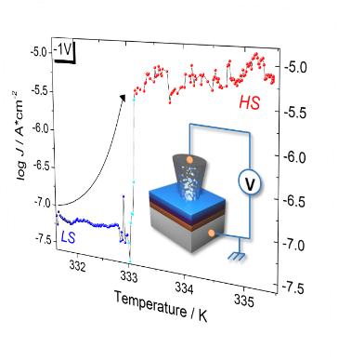

TOC figure

Copyright WILEY-VCH Verlag GmbH & Co. KGaA, 69469 Weinheim, Germany, 2016.

Supporting Information

Vertical tunnel junction embedding a Spin Crossover molecular film

Lorenzo Poggini,* Juan H. González-Estefan, Mathieu Gonidec,* Benoît Gobaut, Patrick Rosa.

 |  | Fe |  | N |  |  | B
 |  |  |  | N_{α} | N_{β}
Experimental |  | 4.8 |  | 64 | 36 |  | 10.9
 |  |  |  | 84.3
Theoretical |  |  |  | 66 | 34
 |  | 4.8 |  | 85.7 |  |  | 9.5

Table S1. Atomic concentration estimated by XPS for SCO thin film (5 nm) evaporated on ^{TS}Au.

Components | A+A’  %; B.E.  (ΔE_{SO}) | B+B’  %; B.E.  (ΔE_{SO}) | C+C’  %; B.E.  (ΔE_{SO}) | D+D’  %; B.E.  (ΔE_{SO}) | E+E’  %; B.E.  (ΔE_{SO})
300K | 26.8%;  709.5 eV (12.5) | 23.4%;  710.4 eV  (13) | 26.7%;  711.9 eV  (13) | 8.5%;  714.9 eV  (13) | 14.6%;  717.9 eV  (13)
350K | 4.2%;  709.7 eV (12.5) | 32.4%;  710.6 eV  (12) | 24.7%;  712.3 eV  (13) | 20.8%;  715.3 eV  (13) | 17.5%;  718.3 eV  (13)
Table S2. Components employed for least squares fitting of the Fe2p XPS Binding Energies (B.E.) of 5 nm SCO deposit on ^{TS}Au. Integrated areas are reported in percentages for each component. Spin-orbit splitting values (ΔESO) are reported in brackets.

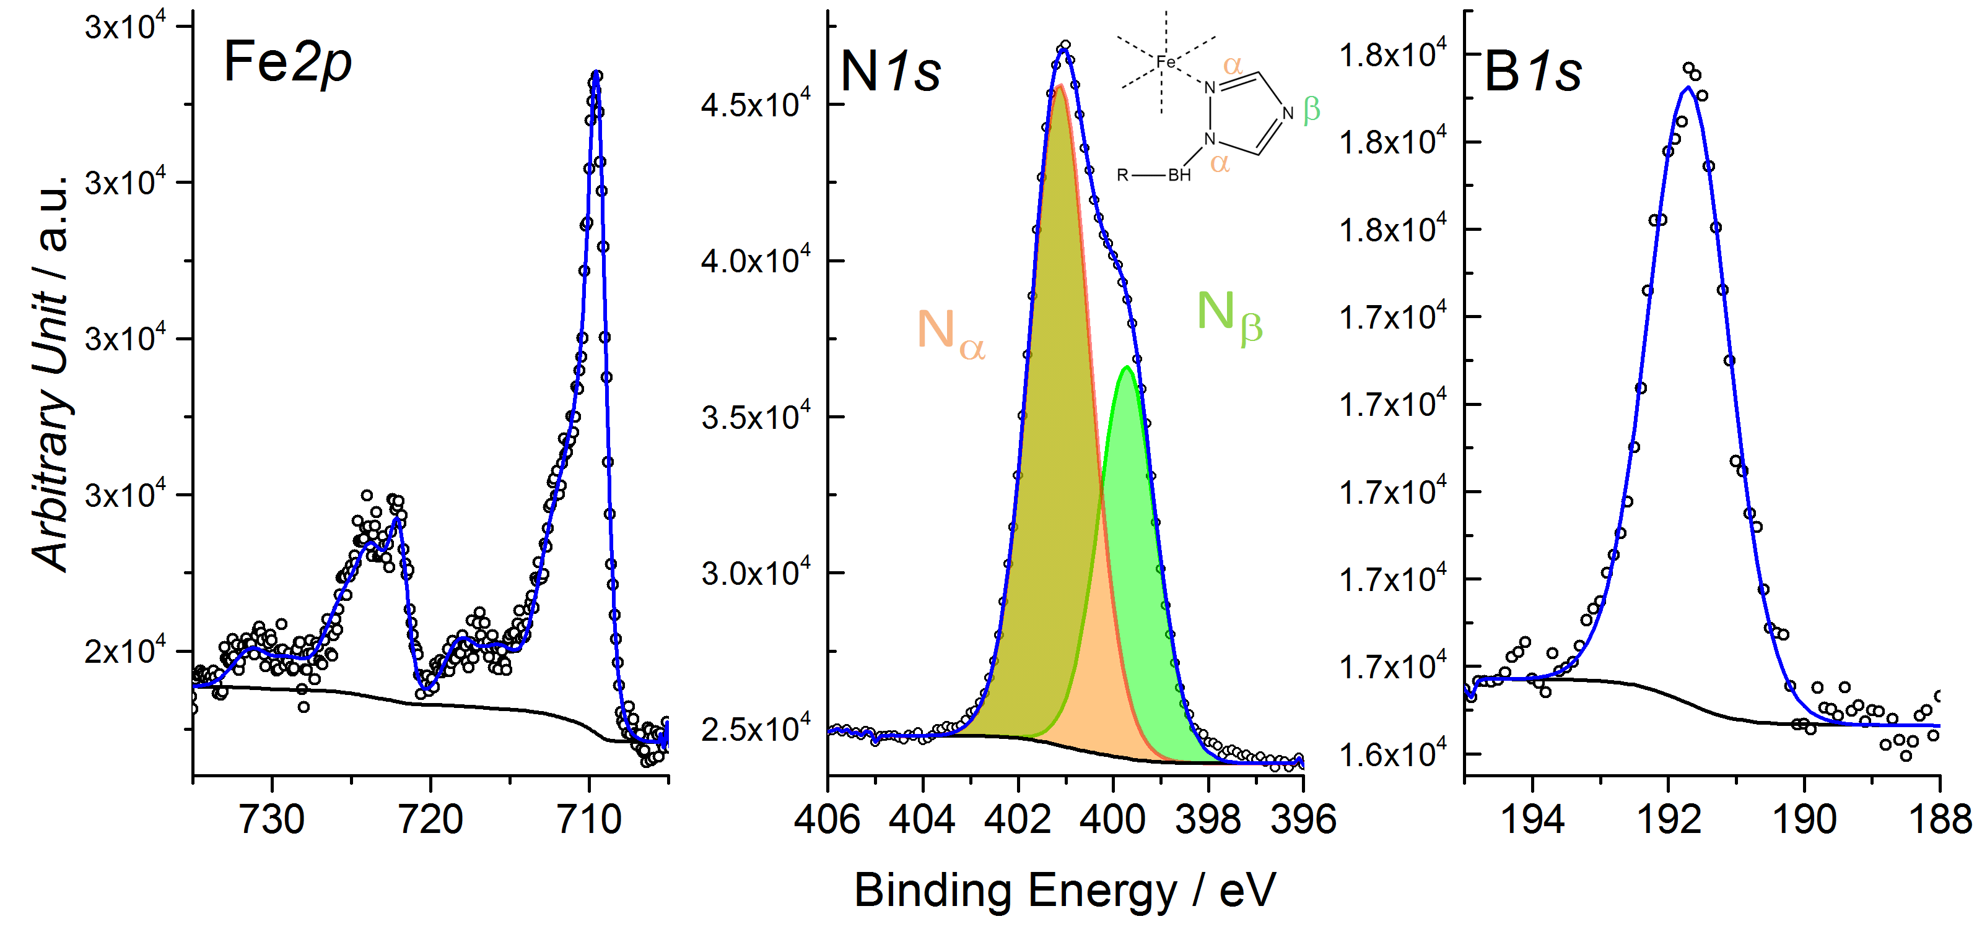
Figure S1. XPS spectra in the region of Fe2p, N1s and B1s with the fit used for estimation of atomic concentrations.
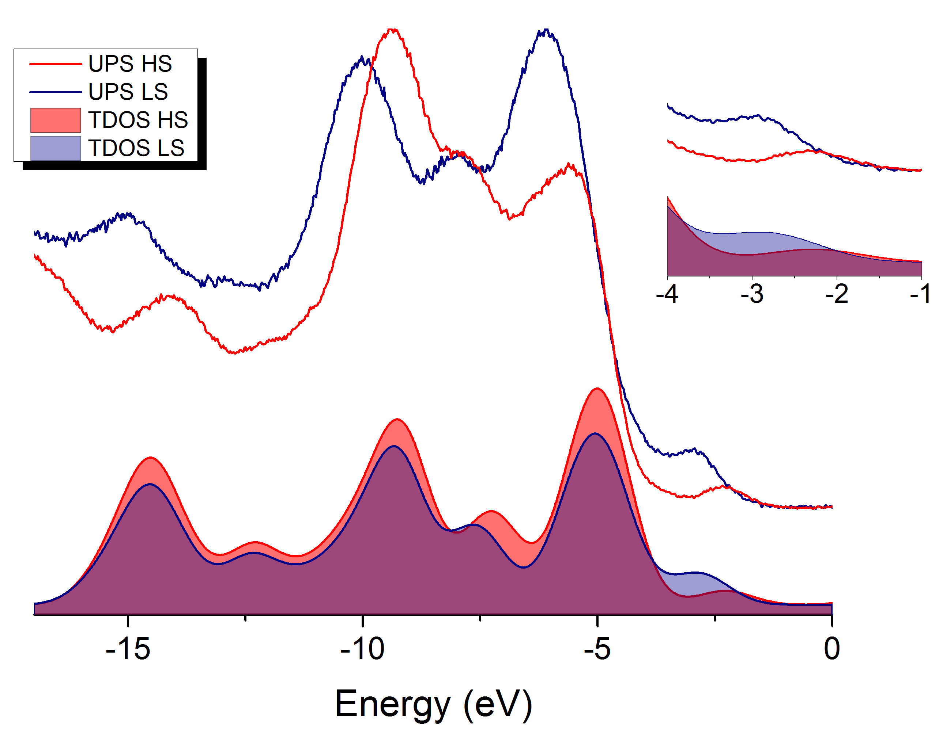
Figure S2. Comparison of the calculated TDOS spectra for the HS and LS states of compound 1, with the experimental UPS spectra measured on thin films on polycrystalline TSAu. Inset, zoom in the valence-Fermi region from -1eV to -4eV to emphasise the SCO transition observed by UPS.

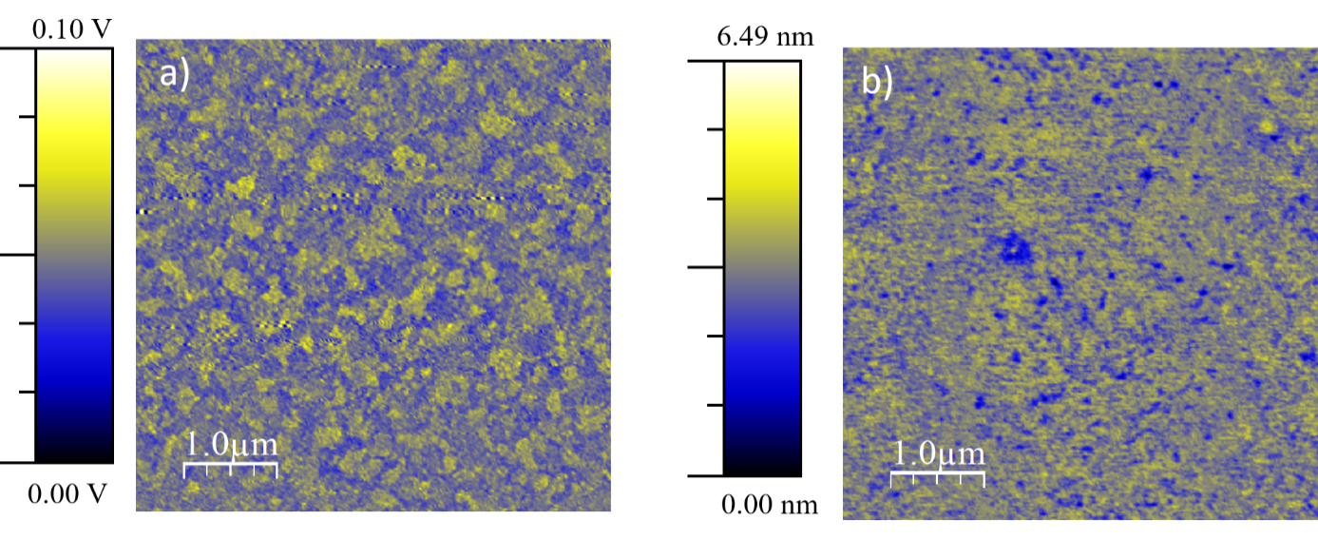
Figure S3. NC-AFM images on bare ^{TS}Au (demodulation) a) and on 5 nm SCO deposit b) (topographic).

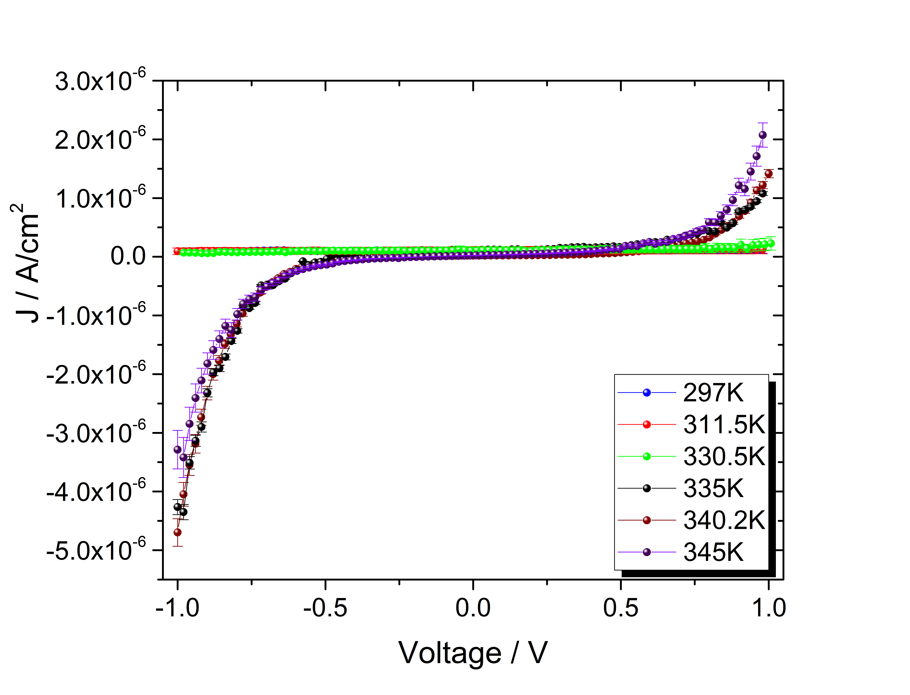
Figure S4. Complete series of J/V curves at different temperature from RT up to 345K.

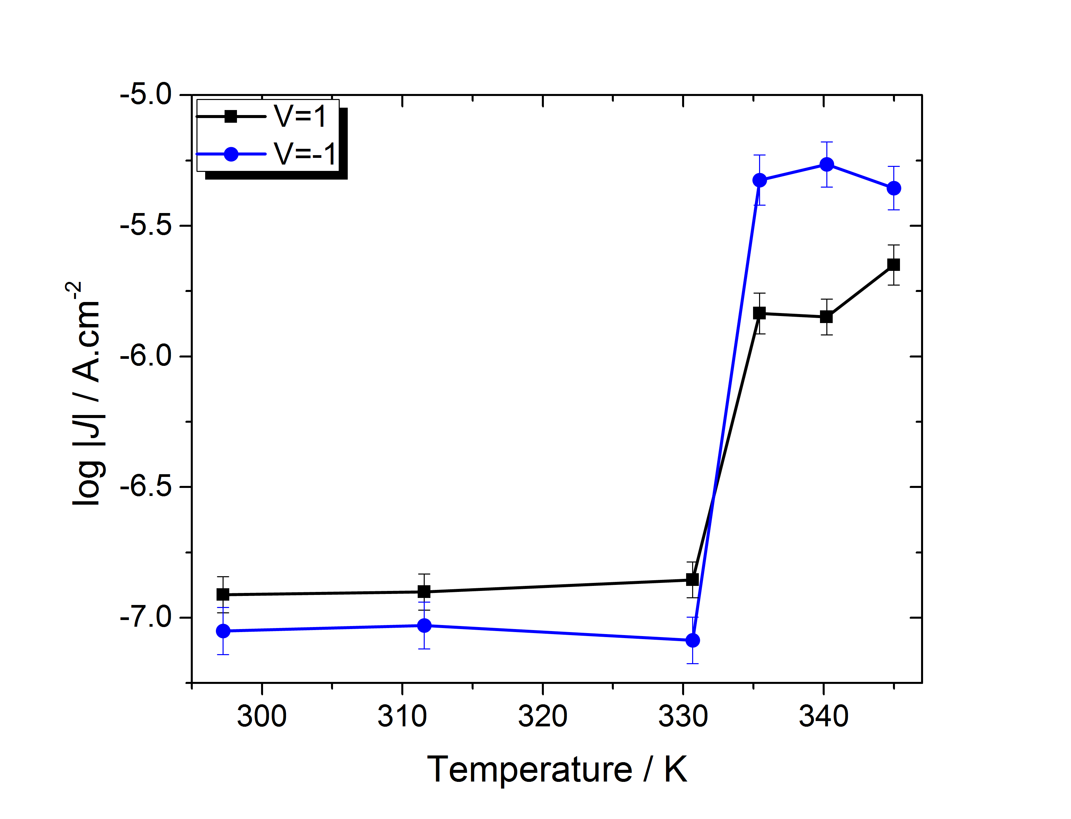
Figure S5. log |J| at two different voltages reported as a function of temperature to emphasize the electrical conductivity switching at the SCO.

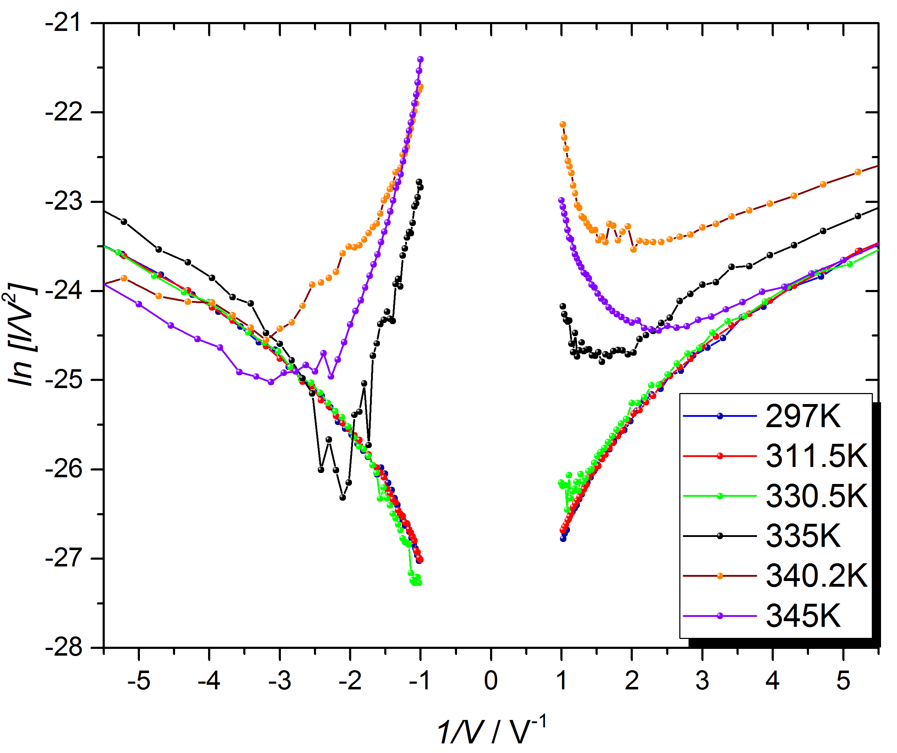
Figure S6. Fowler-Nordheim plot at different temperature.
Mixed Multilayer Simmons-like Model:
The Simmons’ model was developed to describe the J/V characteristics of solid-state inorganic metal-insulator-metal junctions. Despite its simplicity, it has since then been applied successfully by a variety of authors to describe molecular tunnel junctions. To the best of our knowledge this has only been done to rationalize J/V characteristics of monolayer systems composed of a unique molecule and can be written as follows:

$J=J_{0}\left(\left(\overline{φ}-\frac{eV}{2}\right)e^{-A\sqrt{\left(\overline{φ}-\frac{eV}{2}\right)}}-\left(\overline{φ}+\frac{eV}{2}\right)e^{-A\sqrt{\left(\overline{φ}+\frac{eV}{2}\right)}}\right)$ eq.S1
where
$J_{0}= \frac{e}{2πh{\left(βd\right)}^{2}}$ eq.S2
and
$A=\frac{4πβd\sqrt{2m^{*}m_{e}}}{h}$ eq.S3

where, V (in V) is the bias voltage applied to the junction, $\overline{φ}$ (eV) is the average barrier height across the tunnelling barrier, d (Å) is the width of the tunnelling barrier defined by the thickness of the insulating layer, e (C) is the elementary charge, h (J.s) is the Planck constant, β is a dimensionless correction factor close to unity, m_{e} (kg) is the rest mass of the electron and m* is the effective carrier mass in units of true mass of the electron.
In the case of complex junctions such as the spin crossover junctions we describe here, it is not obvious how one should proceed to model such a complex system. Due to the specificity of charge transport by tunnelling, two main questions arise i) how should one model a multilayer structure (as opposed to monolayer or single-molecule junctions) and ii) how should one think about tunnelling through a mixed thin film composed of different molecules with different electronic configurations.
To simplify the treatment of the system, we assume that our multilayer films consist in a cubic arrangement of molecular entities according to the following diagram:

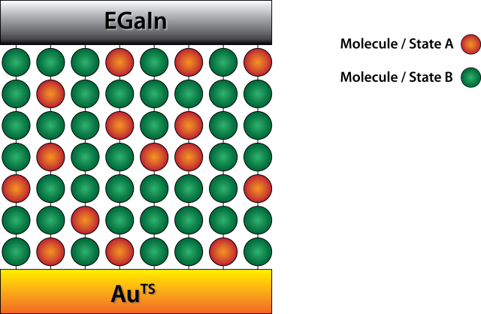
We then assume that they define a combination of vertical series of molecular tunnelling barriers that are laterally associated in parallel transport channels. In this context, we therefore assume that the tunnelling barrier height defined by a vertical column composed of n different molecular species is the average tunnelling barrier of the species composing it such that:

${\overline{φ}}_{v}= \frac{1}{n}\sum_{i=1}^{n}{{\overline{φ}}_{i}}$ eq.S4

And that the tunnelling current density of the mixed multilayer films can be computed by averaging the contribution of the different columns so that:
$J_{ML}=\frac{1}{n_{columns}} \sum_{columns}{J_{0}\left(\left({\overline{φ}}_{v}-\frac{eV}{2}\right)e^{-A\sqrt{\left({\overline{φ}}_{v}-\frac{eV}{2}\right)}}-\left({\overline{φ}}_{v}+\frac{eV}{2}\right)e^{-A\sqrt{\left({\overline{φ}}_{v}+\frac{eV}{2}\right)}}\right)}$ eq.S5
For a multi-layer thin film of SCO molecules, we expect to have a distribution of HS and LS molecules across the thin film, with an overall HS fraction γ_{HS} that is a direct function of temperature and will depend on the compound under study. We assume that this distribution is random and that while performing our measurements we are sampling an area big enough to have a statistical distribution of all of the possible configurations.

Calling n_{HS} the number of molecules in a HS state in a given column, and l the number of molecular layers in the film, P(n_{HS}) is the probability to find n_{HS} molecules in the HS state in any column when the fraction of molecules in HS state in the whole sample is equal to γ_{HS},
$P\left(n_{HS}\right)=\left(\begin{matrix}l \\ n_{HS}\end{matrix}\right)γ_{HS}^{n_{HS}}{\left(1-γ_{HS}\right)}^{l-n_{HS}}$ eq.S6

where, $\left(\begin{matrix}l \\ n_{HS}\end{matrix}\right)$ is the corresponding binomial coefficient:

$\left(\begin{matrix}l \\ n_{HS}\end{matrix}\right) =\frac{l!}{n_{HS}!\left(l-n_{HS}\right)!}$ eq.S7

Calling $J(n_{HS})$ the current density for columns containing n_{HS} molecules in the HS state, then J(γ_{HS}) is the expected current density measured across the sample when the fraction of molecules in HS state in the whole layer is equal to γ_{HS}.

$J\left(γ_{HS}\right)=\sum_{n_{HS}=0}^{l}{P(n_{HS})J(n_{HS})}$ eq.S8

Combining these equations:

$J\left(γ_{HS}\right)=\sum_{n_{HS}=0}^{l}{\frac{l!}{n_{HS}!\left(l-n_{HS}\right)!}γ_{HS}^{n_{HS}}{\left(1-γ_{HS}\right)}^{l-n_{HS}}J(n_{HS})}$ eq.S9

and the values of J(n_{HS}) can be established from the equation for J_{ML.}
Using this formalism one can thus model directly the curves of J(T) by computing the corresponding values of J(γ_{HS}). It is well-known that EGaIn based junctions present much lower values of current density than Metal-Insulator-Metal junctions performed by evaporation of a metallic top-electrode or by using conducting probe AFM. It has been established by Simeone et al¹³ that the difference in tunnelling current density between those two types of junction system is reproducible and leads to a difference of roughly 5 orders of magnitude. We therefore used those empirical corrections to calibrate the current densitities of our model. The results are shown in Fig. S6 and Figure 4b).
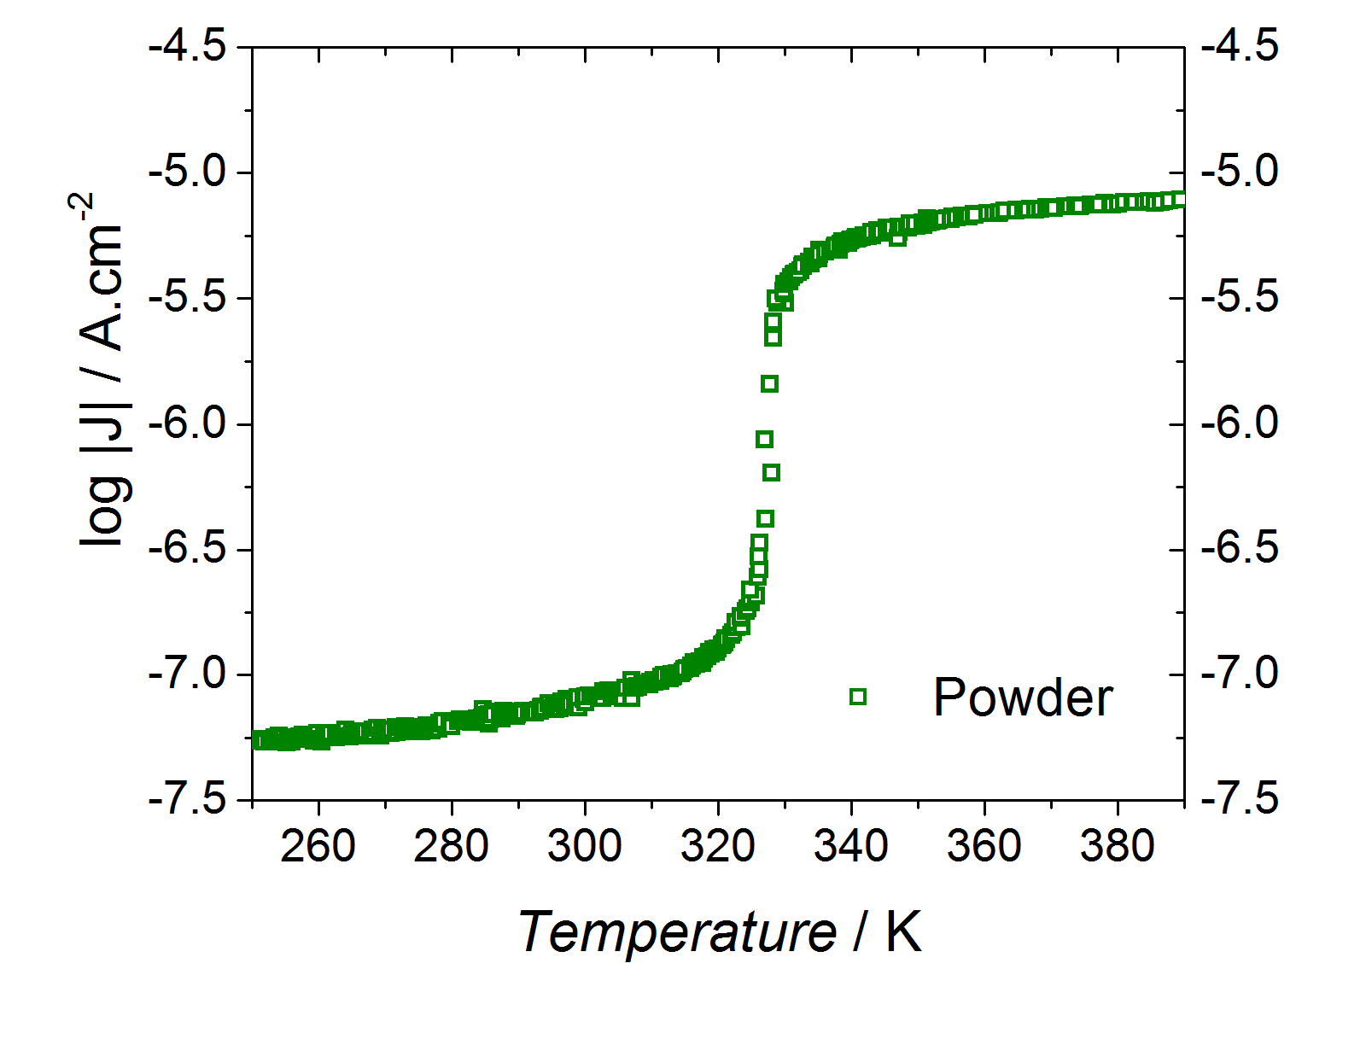
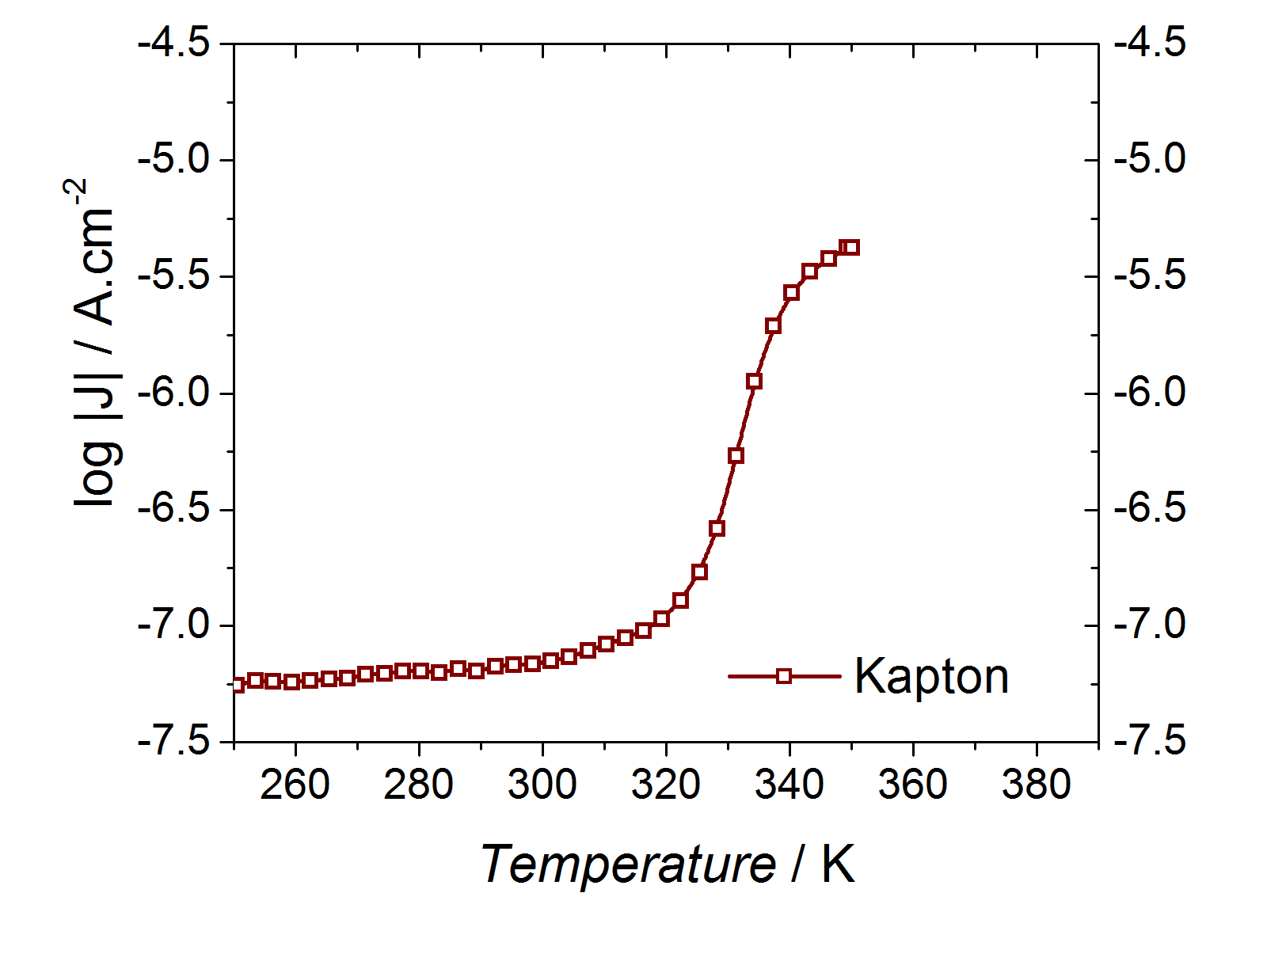
Figure S6. Simulated log |J| vs. T curves at an applied potential bias of 1 V using experimental values of γ_{HS} from magnetic measurements performed on a bulk powder sample (top) and a thin film on Kapton (bottom), respectively.
Figure S7. Comparison of the experimental powder diffractograms for sublimated [Fe(HB(trz)₃)₂] after sublimation, after 2 months and after 3 months, with the pattern calculated from the published structure for the LS phase of the anhydrous complex.

